Project Report:
Uber and Lyft Comparative Analysis: A Data-Driven Method
Group Members
Aamena Zakir Shaikh - NF1005115
Bui Ngoc Mai Khanh - NF1002800
Anisha K C - NF1001648
Heta Chavda - NF1014555
Krishna Patel - NF1017043
DAMO-500-2: Principal of Analytics
Instructor: Abbas Hamze

Introduction
1. Overview of the Ride-Sharing Industry
- By providing accessible, affordable, and adaptable travel options, the sharing-a-ride sector—led by businesses like Uber and Lyft—has entirely altered urban transportation.
- The industry faces obstacles like strong competition, price sensitivity, and fluctuations in the market despite increasing consumer demand.
2. Importance of Pricing in Ride-sharing
- In these extremely competitive markets pricing strategies are crucial for attracting and retaining consumers.
- Especially during peak hours or in areas where services intersect, customers frequently make their ride-sharing decisions on pricing differences between competing platforms.
3. Purpose of the Study
- The purpose of this study is to look at how user switching behavior and customer demand are affected by price differences between Uber and Lyft.
- The study offers useful information for pricing approaches and customer engagement by investigating the relationship between price and customer choice.
Challenges of the Ride-Sharing Industry
Intense Competition:
- Ride-sharing services like Uber and Lyft compete with highly competitive industries, frequently participating in price wars to attract and keep users.
- Sustainability and profit margins are under pressure as a result.

Price Sensitivity and Switching Behavior:
- Many users are highly price-sensitive and often switch platforms to save money.
- This lack of loyalty makes it challenging for companies to establish a stable customer base.

Demand Volatility:
- Unpredictable demand trends are generated by external factors such as location, weather, incidents, and time of day.
- In order to control demand, companies use surge pricing, which may drive away customers and send them to compete companies.
Balancing Pricing and Profitability:
- Platforms must attract price-sensitive users while avoiding unsustainable discounts, ensuring competitive yet profitable pricing strategies.
Customer Retention and Satisfaction:
- Insights from the study help design personalized rewards and improve services to retain customers and enhance satisfaction.
Relevance of the Study to These Challenges
Understanding User Switching Behavior:
- The study examines how price differences influence users to switch between Uber and Lyft, providing insights into user preferences.
Optimizing Pricing Strategies:
By identifying the impact of price on user choice, the research helps ride-sharing platforms design competitive yet profitable pricing strategies.
Addressing Market Competition:
The findings offer guidance on balancing affordability and service differentiation to attract and retain customers.
Improving Customer Retention:
Insights from the study can aid in developing loyalty programs or targeted offers that minimize switching behavior.
How the Study Addresses the Problem
This research investigates:
Whether there is a significant price difference between Uber and Lyft.
How price differences influence the likelihood of users choosing one platform over the other.
By addressing these questions, the study provides data-driven recommendations for navigating price sensitivity and improving customer retention in a competitive environment.

Data description
The Uber & Lyft Cab Prices dataset provides detailed information on ride-sharing services, focusing on pricing and related factors. Below is a description of the dataset's columns:
- cab_type
  - Description: Indicates the ride service provider, either Uber or Lyft.
  - Type: Categorical (e.g., 'Uber', 'Lyft').
- price
  - Description: The fare charged for the ride, in dollars.
  - Type: Numeric (e.g., 15.50).
- distance
  - Description: The length of the trip in miles.
  - Type: Numeric (e.g., 3.2).
- time_stamp
  - Description: The date and time when the ride was requested.
  - Type: DateTime (e.g., '2018-11-26 08:37:00').
- surge_multiplier
  - Description: Surge pricing factor applied during high-demand periods.
  - Type: Numeric (e.g., 1.0 indicates no surge, 1.5 indicates a 50% increase).
- source
  - Description: The pickup location for the ride.
  - Type: Categorical (e.g., 'Back Bay', 'North End').
- destination
  - Description: The drop-off location for the ride.
  - Type: Categorical (e.g., 'Beacon Hill', 'South Station').
- ride_type
  - Description: The category of the ride service (e.g., 'UberX', 'Lyft Lux').
  - Type: Categorical.
- id
  - Description: Unique identifier for each ride entry.
  - Type: String (e.g., 'abc123').

Note: The dataset was collected around Boston, Massachusetts, between November and December 2018.

Research Question: How do price differences between Uber and Lyft influence user switching behavior and market demand?
To address this question, we further break it into two smaller hypotheses that need testing:
  - Is there a difference in the distribution of users between the two services?
  - Is there a difference in the prices of rides between Uber and Lyft?
  - Does the variation in ride-sharing prices have no significant impact on users' platform selection?
Hypothesis 1:
- H0_1: There is no difference in the distribution of users between the two services.
- H1_1: There is a difference in the distribution of users between the two services.

Hypothesis 2:
- H0_2: There is no price difference between Uber and Lyft.
- H1_2: There is a price difference between Uber and Lyft.
Hypothesis 3:
- H0_3: Price differences do not affect user choice.
- H1_3: Price differences affect user choice.

Methodology
Statistical Test: Chi-squared Test.
For research question 1, the first hypothesis, we aim to determine whether the number of users taking Uber and Lyft are significantly different, or equivalently, whether the users of Uber and Lyft are distributed equally. To investigate this, we use a Chi-Square Test for Homogeneity, ensuring that the data were collected through random sampling and that all expected counts are at least 5. The hypotheses are defined as follows:
H₀: $ρ_{Uber}=ρ_{Lyft}$
H₁: $ρ_{Uber}≠ρ_{Lyft}$
Concerning research question 1, the second hypothesis, to evaluate whether there is a significant difference in ride prices between Uber and Lyft, we use a two-sample t-test to compare the mean prices of the two services. Despite the t-test typically being applied to smaller samples, the large dataset (approximately 650,000 records) ensures the sampling distribution of the mean is approximately normal. This method is appropriate since the t-test does not require knowledge of the population standard deviation for Uber and Lyft prices. The hypothesis being tested is that the population means of the two samples are equal, assuming equal variances between the groups. Therefore, the hypothesis 1 can also be defined as

H₀: $μ_{Uber}=μ_{Lyft}$
H₁: $μ_{Uber}≠μ_{Lyft}$
Results
Research question 1 – hypothesis 1:
The p-value (5.19892E-18) effectively validates that there is statistical evidence of the distribution of Uber and Lyft users.

Chi-squared statistics | 307.5902418
p-value | 5.19892E-18

We can see this trend clearly when visualizing the data

Figure 1. Distribution of Uber and Lyft User
Research question 1 – hypothesis 2:
The test results for a two-sample comparison are given in Table 3. The small p-value (effectively 0) suggests that there is a statistically significant difference between Uber's and Lyft's ride-prices. Figures 2 and 3 describe the average cab fare for Uber and Lyft, where the average Uber ride fare (US$15.8) is lower than that of Lyft (US$17.4).

Statistical Test: Two-Sample T-Test (Assuming Unequal Variances).
Purpose:
- Compare the average prices of Uber and Lyft.
- Test if the difference is statistically significant.
Steps:
- Calculate the mean and variance of prices for both Uber and Lyft.
- Perform the t-test using a significance level of 0.05.

Two samples t-test
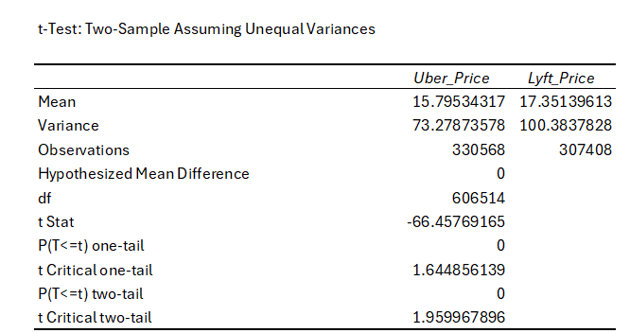
Key Observations:
Means:
- Uber Price Mean: 15.79
- Lyft Price Mean: 17.35
- Lyft prices are higher on average compared to Uber.
Variance:
- Uber Price Variance: 73.28
- Lyft Price Variance: 100.38
- Lyft prices are more variable than Uber prices.
t-Statistic:
- t Stat: -66.46
- A very large negative t-statistic indicates a substantial difference in means.
p-Value:
- P(T<=t) two-tail: 0
- Since the p-value is effectively 0 (less than 0.05), we reject the null hypothesis (H0_1). This indicates that there is a statistically significant difference in prices between Uber and Lyft.

Critical t-Value:
- The t-statistic (-66.46) is far beyond the critical values for both one-tail and two-tail tests, further supporting the rejection of the null hypothesis.
Visualization:
Figure 2. The average price of rides for Lyft vs. Uber
- Figure 3. Average price by distance
- From Figure 3, we can observe that for long-distance trips (distances exceeding 5 miles), Lyft tends to have a higher price. Therefore, it is advisable to opt for Uber in such cases. However, for short-distance trips (distances less than 5 miles), Uber can occasionally have higher costs.
Conclusion for Hypothesis 1 and 2:
- H0_1: There is no difference in the distribution of users between the two services→ Rejected.
- H1_1: There is a difference in the distribution of users between the two services→ Accepted.
- H0_2: There is no price difference between Uber and Lyft → Rejected.
- H1_2: There is a price difference between Uber and Lyft → Accepted.
This means there is a significant price difference between Uber and Lyft.
Recommendations:
For Lyft:
- Highlight value-for-money perception in marketing to justify higher pricing.
For Uber:
- Leverage lower pricing as a competitive advantage to attract price-sensitive users.
Hypothesis 3:
- H0_3: Price differences do not affect user choice.
- H1_3: Price differences affect user choice.

Methodology
Statistical Test: Logistic Regression.
Purpose:
- Analyze how price affects the likelihood of choosing Lyft over Uber.
Dependent Variable:
- is_lyft (1 for Lyft, 0 for Uber).
Independent Variable:
- price.
Regression
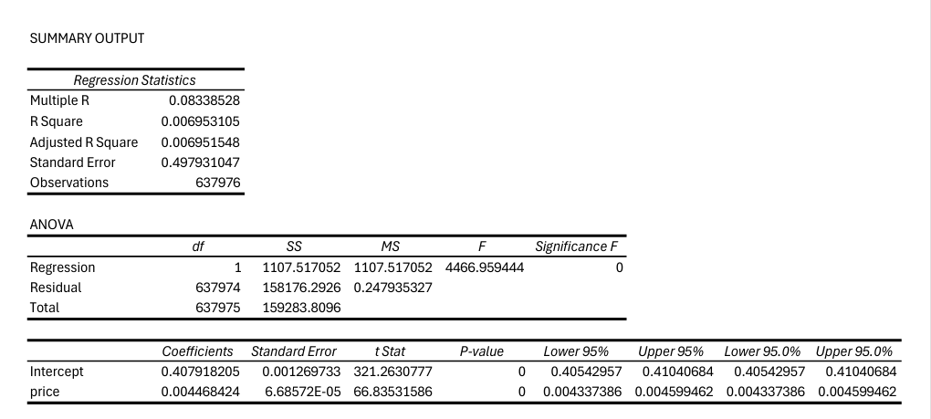
Result:
Regression Statistics:
- R-Square: 0.00695 (price explains 0.695% of user choice variation).
- Coefficients:
  - Intercept: 0.4079
  - Price Coefficient: 0.0045 (positive, p-value = 0).
Conclusion:
- The null hypothesis (H0_3) is rejected.
- Price significantly influences user choice, but the effect size is small.
Recommendations:
For Lyft:
- Focus on competitive pricing but also improve service quality to attract users.
For Uber:
- Justify higher pricing with premium features or loyalty programs.
For Both:
- Investigate other factors (e.g., surge pricing, distance, service quality) as price alone does not strongly predict user choice.
2. Research Question 2
What are the most common distance ranges for rides in the area, and how do these distances correlate with the average fare and cab type (Uber vs. Lyft)?
- H0: Distance does not significantly correlate with average fare or differ by cab type (Uber vs. Lyft).
- H1: Distance significantly correlates with average fare and differs by cab type (Uber vs. Lyft).

Methodology:
1. Data Grouping and Descriptive Analysis
Distance Ranges:
Rides were grouped into distance ranges: 0-1 miles, 1-3 miles, 3-5 miles, and 5-10 miles.
A pivot table was created to count the number of rides in each range and calculate average fares for Uber and Lyft separately.
Comparison by Cab Type:
Average fares were computed for each distance range, split by cab type (Uber and Lyft).
Correlation:
The CORREL function in Excel was used to measure the relationship between distance and fare.
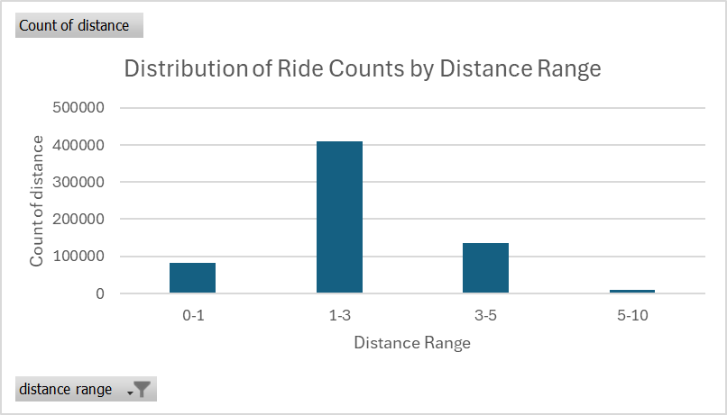
Visualization:

Distance Range | Count of distance
0-1 | 81858
1-3 | 409796
3-5 | 136224
5-10 | 10098
Grand Total | 637976

Results
- Most Common Distance Range:
  - The 1–3-mile range is the most common, accounting for over 64% of all rides.
- Average Fares by Cab Type:
  - Lyft consistently charges higher fares than Uber across all distance ranges.
- Correlation:
  - A weak to moderate positive correlation (0.345) exists between distance and fare.
Conclusion
- Short-distance trips dominate, with 1-3 miles being the most common range.
- Lyft charges higher fares compared to Uber across all distances, reflecting a premium pricing strategy.
- Distance has a weak to moderate influence on fare, suggesting other factors like surge pricing and ride type also play significant roles.
Recommendations
- For Lyft:
  - Consider competitive pricing for short-distance trips (1-3 miles) to capture more of the market.

- For Uber:
  - Emphasize affordability in marketing for short-distance trips to attract price-sensitive users.
- For Both:
  - Explore additional factors like surge pricing and ride type to refine pricing strategies and optimize user satisfaction.

2. ANOVA
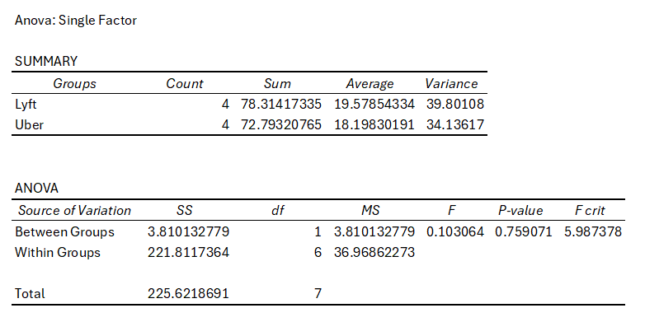
ANOVA Results Interpretation
Summary of the Analysis
Groups Compared:
- Lyft: Average fare = $19.58, Variance = 39.80.
- Uber: Average fare = $18.20, Variance = 34.14.
ANOVA Table:
- F-Statistic: 0.103.
- P-Value: 0.759.
- F Critical: 5.987.
Interpretation of Results
P-Value (0.759):
- The p-value is greater than 0.05, meaning the difference in average fares between Lyft and Uber across distance ranges is not statistically significant.
- We fail to reject the null hypothesis (H0), suggesting there is no significant difference in average fares between Uber and Lyft.
F-Statistic (0.103) vs. F Critical (5.987):
- Since the F-statistic is less than the critical F-value, the variation between the two groups (Lyft and Uber) is not large enough to be statistically significant.
Conclusion
Fares:
- While Lyft has a slightly higher average fare ($19.58) compared to Uber ($18.20), this difference is not statistically significant.
- Variations in fares are likely due to factors other than cab type.
Distance Ranges:
- The analysis does not find significant differences in fares across distance ranges between Uber and Lyft.
Recommendations
Lyft and Uber:
- Since fare differences are not statistically significant, both companies should focus on differentiating their services (e.g., quality, availability) rather than relying solely on pricing.
Further Analysis:
- Incorporate other variables (e.g., surge_multiplier, ride_type, time_of_day) into the analysis to better understand fare differences.
- Use two-way ANOVA to assess the interaction between distance ranges and cab type.

